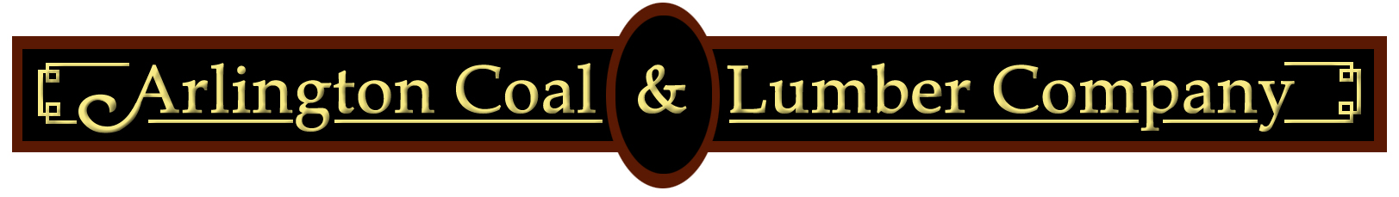 | 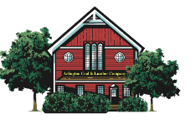

Credit Card Authorization

Customer NAME
COMPANY NAME
Address
City, STate, Zip
Phone
Email Address

Amex | Visa |  | Master Card | Discover
Credit Card Number
Cardholder Name
Expiration Date
Card Security Code
Billing Zip Code

Authorized users

I hereby authorize the above individuals to sign for purchases on my behalf using the credit card information above. I understand I may revoke this privilege to any individual at any time either in writing or by verbal notification to the respective locations.
Cardholder signature | Date
*VALID AT ALL ARLINGTON COAL & LUMBER CO LOCATIONS
Arlington Coal & Lumber – 41 Park Ave Arlington, MA Hudson Lumber – 261 Lowell Rd Hudson, NH
Burlington Lumber – 4 Adams St Burlington, MA Sudbury Lumber – 28 Union Ave Sudbury, MA
Chelmsford Lumber – 201 Boston Rd Chelmsford, MA Wilmington Builders – 334 Main St Wilmington, MA

